**NAME**

**REG NUMBER**

**Classwork One**

1. Write a program to print the numbers less than 10 and print their squares

//QUESTION ONE NUMBERS >10 AND THEIR SQUARES

#include <iostream>

using namespace std;

int main()

{

    int k;

    cout << "Enter an integer to print: ";

    cin >> k;

    if (k < 10)

    {

    cout << k << "is less than 10: " <<  endl;

        cout << "Square of the number is:" << n*n<< endl;

    }

    cout << "I like C++ programming";

}

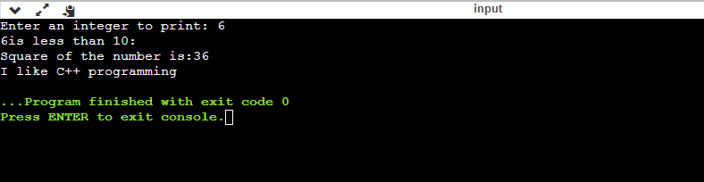

**Question Two**

1. **Write a program to check if a number is odd or even**

#include <iostream>

using namespace std;

int main()

{

      int k;

    cout<< "Enter an integer to detect:";

    cin>> k;

    if(k%2==0)

    {

        cout<<k<<"is even.";

    }

    else{

        cout<<k<<"is odd.";

    }

}

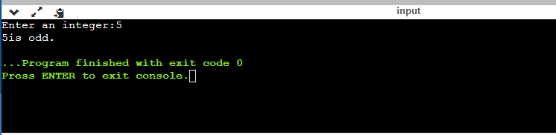

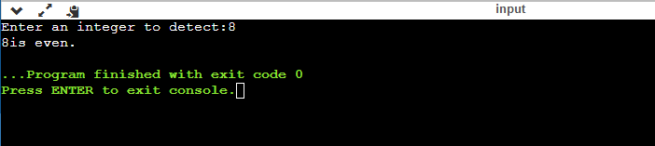

**Question 3**

* Write a program to check if a number is positive or negative

#include <iostream>

using namespace std;

int main()

{

       int k;

    cout<< "Enter an integer:";

    cin>> k;

    if(k>0)

    {

        cout<<k<<"is Positive";

    }

    else if (k==0)

    {

        cout<<k<<"is zero";

    }

    else

    {

    cout<<k<<"is Negative";

    }

}

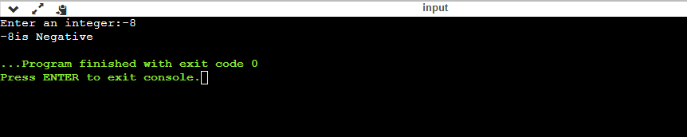

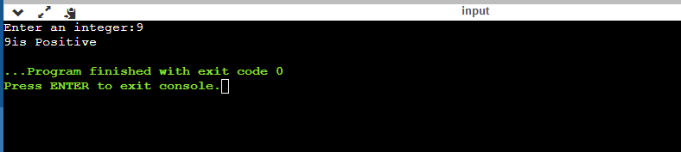

**Question 4**

1. Program to find maximum between two numbers using if else. C++   
   program to input two numbers from user and find maximum between two numbers using if else.

#include <iostream>

using namespace std;

int main()

{

       int x,y;

    cout<< "Please enter the 1st integer number:";

    cin>> x;

    cout<< "Please enter the 2nd integer  number:";

    cin>> y;

    if(x>y)

    {

        cout<< x <<"is Max";

    }

    else if (y>x)

    {

        cout<< y <<"is Max";

    }

    else

    {

    cout<< x <<"&" << y << "equal";

    }

}

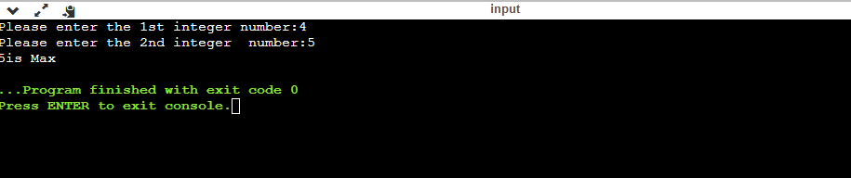

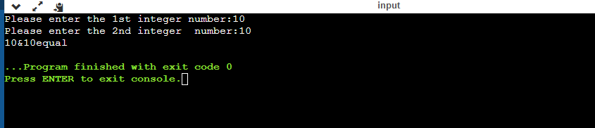

**Question 5**

1. Print student marks and show grades

#include <iostream>

using namespace std;

int main()

{

    float G;

    cout<< "Please enter your mark:";

    cin>> G;

    if(G>= 90)

    {

        cout<< "your Grade is A";

    }

    else if (G>= 85)

    {

        cout<<"your Grade is B";

    }

    else if (G>= 75)

    {

        cout<<"your Grade is C";

    }

    else if (G>= 60)

    {

        cout<< "your Grade is D";

    }

    else

    {

        cout<< "your Grade is F";

    }

    return 0;

}

